Stroke patients show promising signs of recovery after stem cell therapy
The pilot study was only designed to test safety, but a larger trial of the pioneering stem cell treatment is planned for next year
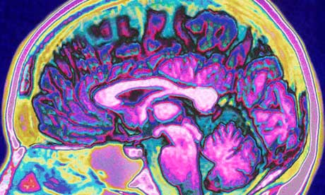
The stem cells may work by releasing chemicals that dampen down inflammation and help other cells to grow where tissue was damaged by the stroke. Photograph: Corbis
Stroke patients who took part in a small pilot study of a stem cell therapy have shown tentative signs of recovery six months after receiving the treatment.
Doctors said the condition of all five patients had improved after the therapy, but that larger trials were needed to confirm whether the stem cells played any part in their progress. Scans of the patients' brains found that damage caused by the stroke had reduced over time, but similar improvements are often seen in stroke patients as part of the normal recovery process.
At a six-month check-up, all of the patients fared better on standard measures of disability and impairment caused by stroke, but again their improvement may have happened with standard hospital care. The pilot study was designed to assess only the safety of the experimental therapy and with so few patients and no control group to compare them with, it is impossible to draw conclusions about the effectiveness of the treatment.
Paul Bentley, a consultant neurologist at Imperial College London, said his group was applying for funding to run a more powerful randomised controlled trial on the therapy, which could see around 50 patients treated next year.
"The improvements we saw in these patients are very encouraging, but it's too early to draw definitive conclusions about the effectiveness of the therapy," said Soma Banerjee, a lead author and consultant in stroke medicine at Imperial College Healthcare NHS Trust. "We need to do more tests to work out the best dose and timescale for treatment before starting larger trials."
The five patients in the pilot study were treated within seven days of suffering a severe stroke. Each had a bone marrow sample taken, from which the scientists extracted stem cells that give rise to blood cells and blood vessel lining cells. These stem cells were infused into an artery that supplied blood to the brain.
The stem cells, called CD34+ cells, do not grow into fresh brain tissue, but might work by releasing chemicals that may dampen down inflammation and help other cells to grow where brain tissue is damaged. Some of the cells might also grow into new blood vessels, Bentley said.
Four out of five of the patients had the most serious type of stroke. Normally only 4% of these patients survive and are able to live independently after six months. In the pilot study, published in Stem Cells Translational Medicine, all four were alive and three were independent six months later.
"Although they mention some improvement of some of the patients, this could be just chance, or wishful thinking, or due to the special care these patients may have received simply because they were in a trial," said Robin Lovell-Badge, head of developmental genetics at the MRC's National Institute for Medical Research in London.

